P.SIRISHA

192110113

CSE

1.Simple intrest using oops concept with argument

import java.util.\*;

class Intrest

{

Intrest(int p,int t,int r)

{

int si=p\*t\*r/100;

System.out.print(si);

}

}

class simple

{

public static void main(String args[])

{

Intrest obj=new Intrest(100,200,300);

}

}

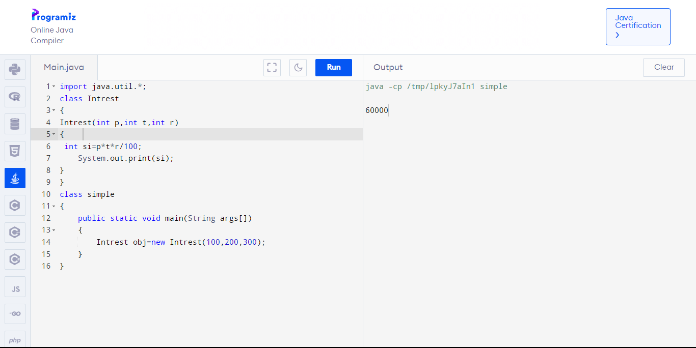

2.Factorial using oops

import java.util.\*;

class Factorial

{

int i,n,fact=1;

void cal()

{

Scanner s=new Scanner(System.in);

System.out.println("enter number");

n=s.nextInt();

for(i=1;i<=n;i++)

fact=fact\*i;

System.out.println(fact);

}

}

class fact

{

public static void main(String args[])

{

Factorial obj=new Factorial();

obj.fact();

}

}

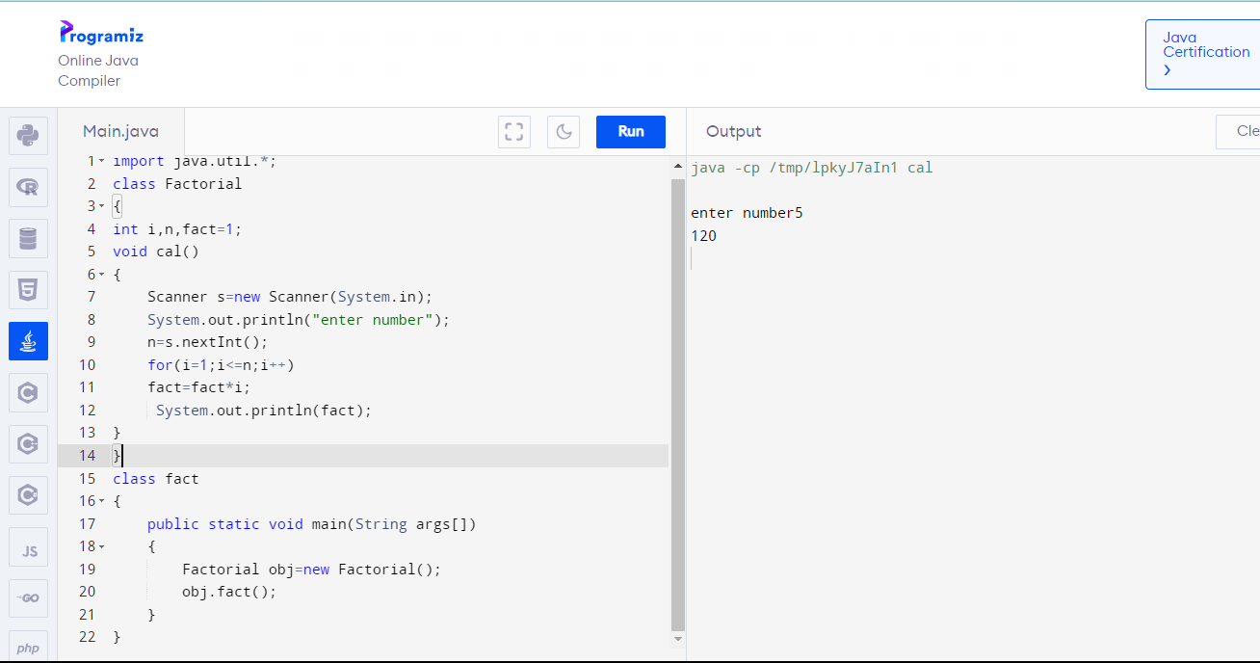

3.multi level inheritance for area of circle,volume of cylinder and cone

import java.util.\*;

class sup

{

double r,area;

void call()

{

Scanner s=new Scanner(System.in);

System.out.println("enter radius");

r=s.nextInt();

area=3.14\*r\*r;

System.out.println(area);

}

}

class cylinder extends sup

{

double r,h,volume;

void get()

{

Scanner s=new Scanner(System.in);

System.out.println("enter height");

h=s.nextInt();

volume=area\*h;

System.out.println(volume);

}

}

class Cone extends cylinder

{

double r,h,volume1;

void put()

{

volume1=1/3\*volume;

System.out.println(volume1);

}

}

class over

{

public static void main(String args[])

{

Cone obj=new Cone();

obj.call();

obj.get();

obj.put();

}

}

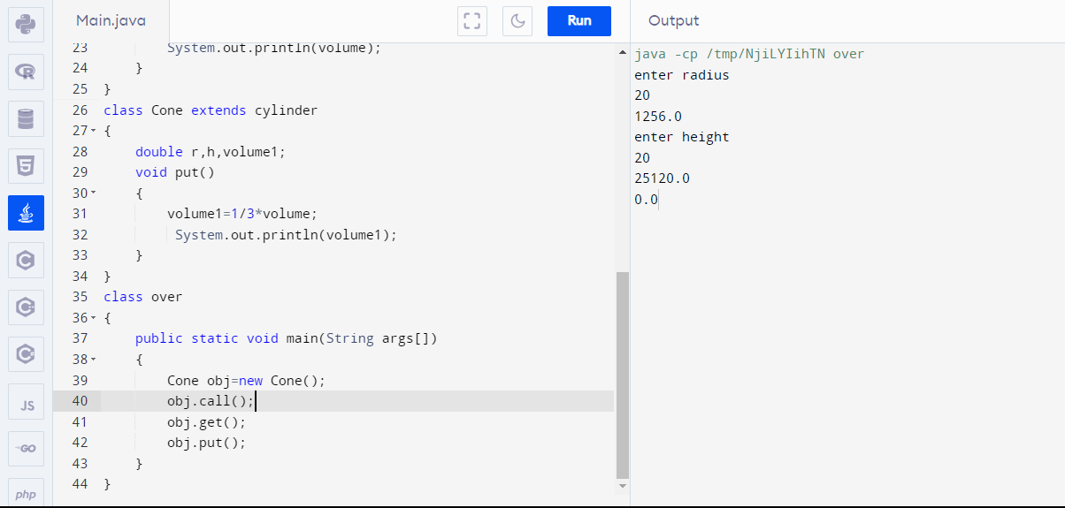

4.Method Overload to print String

import java.util.\*;

class Over

{

void welcome()

{

System.out.println("welcome to java");

}

void welcome(String a)

{

for(int i=0;i<2;i++)

System.out.println(a);

}

void welcome(String a,int b)

{

for(int i=1;i<4;i++)

System.out.println("result is"+a+b);

}

}

class overload

{

public static void main(String args[])

{

Over obj=new Over();

obj.welcome();

obj.welcome("welcome to polymorphism");

obj.welcome("welcome to overloading");

}

}

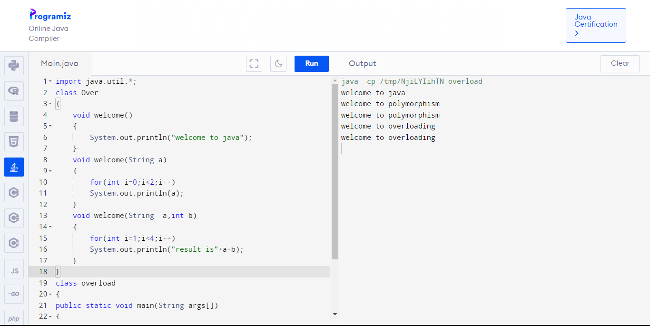

5.Method overloading

import java.util.\*;

class Over

{

void test()

{

System.out.println("no parameter");

}

void test(int a)

{

System.out.println(a);

}

void test(int a,int b)

{

System.out.println("result is"+a+b);

}

void test(int a,double b)

{

System.out.println("result is"+a+b);

}

}

class overload

{

public static void main(String args[])

{

Over obj=new Over();

obj.test(10);

obj.test(10,20);

obj.test(1,2.2);

}

}

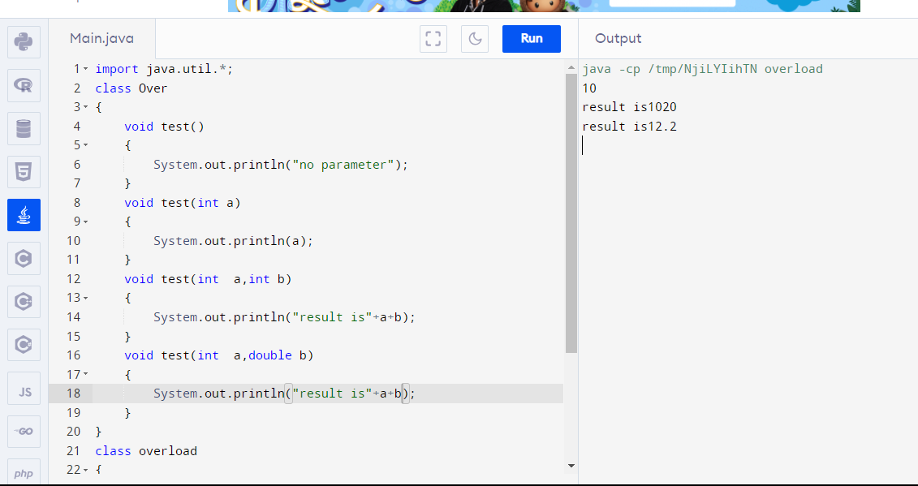

6.Argument Constructor

import java.util.\*;

class Add

{

Add(int a,int b)

{

int c=a+b;

System.out.println(c);

}

}

class calculate

{

public static void main(String args[])

{

Add obj=new Add(1,2);

}

}

